AddCoins Mastery Assignment
Error log
Stefan S
CSE 2110 Procedural Programming 1
(AddCoins.java)
Describe the errors you’ve encountered while working on this assignment. What caused the error and how do you overcome the error?
Partway through making the program, I decided to create a method to handle inputs and was given this result:
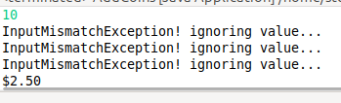
For whatever reason, the following code would cause inputHandling() to execute properly once, and then throw an inputMismatchException for each following execution.
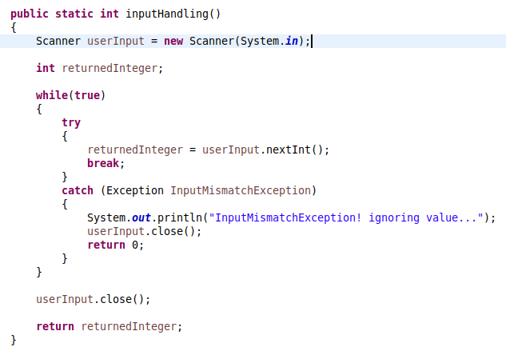
Somehow, this was solved by replacing userInput.close(); with userInput.nextLine();. As far as I’m aware this (effectively) clears whatever value is currently stored by the Scanner, as opposed to close() which does not.

